SItecore MAUI SDK

MAUI software development kit for Sitecore

Sitecore MAUI SDK

Version 1.0.0.0

Version history

|  |  |
| --- | --- |
| Version | Release details |
| 1.0.0.0 | * Alpha version |

Table of Contents

1 What is .NET MAUI 3

2 What is Sitecore MAUI SDK 3

3 Get started 4

3.1 Quick start and build your first app 4

3.2 Types 5

3.3 Setup and installation 5

3.3.1 Pre requisites 5

3.3.2 Setup 5

4 Sitecore MAUI SDK’s 6

4.1 Page types 6

4.1.1 Static page 6

4.1.2 Sitecore page 6

4.1.3 Hybrid page 7

4.2 Consideration 7

4.2.1 Mobile development consideration 7

# What is .NET MAUI

.NET Multi-platform App UI (.NET MAUI) is a cross-platform framework for creating native mobile and desktop apps with C# and XAML.

Using .NET MAUI, you can develop apps that can run on Android, iOS, macOS, and Windows from a single shared code-base.

Refer more: [Microsoft MAUI documentation](https://docs.microsoft.com/en-us/dotnet/maui/what-is-maui)

# What is Sitecore MAUI SDK

Sitecore Headless Development is based on a rendering front end and a Sitecore instance back end. This decoupling of logic domains makes a Sitecore solution easy to develop, maintain, scale, and upgrade.

Sitecore MAUI SDK helps you to consume headless service presentations and help to transform in to composed pages.

Refer more: [https://sitecoremaui.wordpress.com](https://sitecoremaui.wordpress.com/)

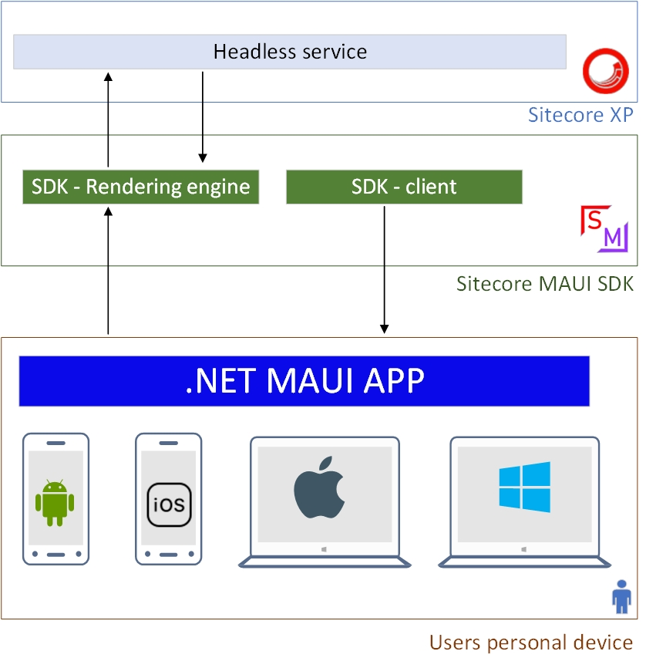

# Get started

## Quick start and build your first app

Quick start and create your first .NET MAUI APP using Sitecore MAUI SDK. Go to the below GIT and clone the sample application.

**Sample Demo bank**: <https://github.com/andiappan-ar/Sitecore.DemoBank/tree/master/Src/MAUI>

Follow the setup procedures. Your app is ready like below,

|  |
| --- |
| Desktop MAUI app |

|  |
| --- |
| Android/IOS MAUI app |

## Types

.Net MAUI apps have two types of technology,

* .NET MAUI Blazor apps
  + This is code based and using Blazor UI components. Sitecore MAUI SDK is ready to use.
* .NET Multi-platform App UI (.NET MAUI)
  + This is code/XAML based. Sitecore MAUI SDK is in preogress.

## Setup and installation

### Pre requisites

Considering the MAUI development below consolidated pre requisites on each area.

1. Sitecore
   1. Headless service
2. Visual studio preview
   1. MAUI installation

### Setup

Please follow setups steps [here](https://github.com/andiappan-ar/Sitecore.DemoBank/tree/master/Src/MAUI#setup).

Ref: <https://github.com/andiappan-ar/Sitecore.DemoBank/tree/master/Src/MAUI#setup>

# Sitecore MAUI SDK’s

## Page types

In MAUI Sitecore SDK there is different types of pages available.

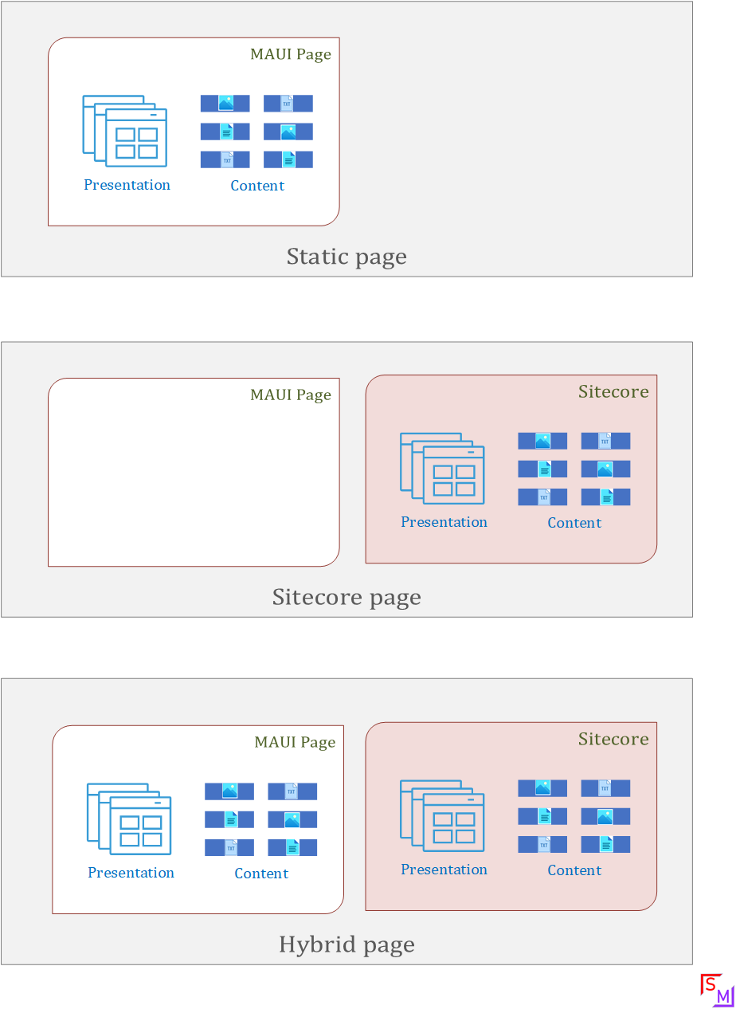

### Static page

Static page contains the presentation and content with in itself. You cannot rely on Sitecore for rendering this page.

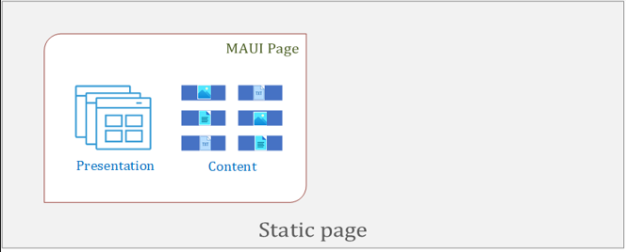

### Sitecore page

Sitecore page is completely rely on Sitecore. This page presentation, content will come from Sitecore.

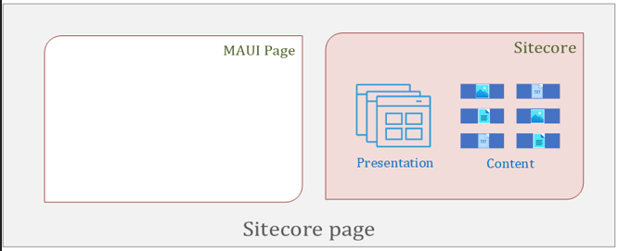

### Hybrid page

Hybrid page is flexible page. You can get content from Sitecore or you can have a static content wit in itself.

Also, Sitecore presentation also can be change by adding your static components.

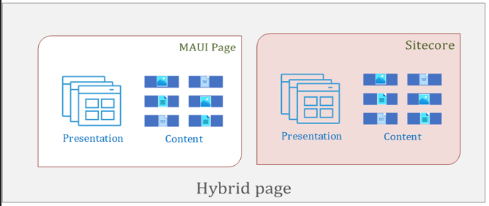

## Consideration

### Mobile development consideration

While you are debug or testing the Sitecore MAUI app from your local. Check your Sitecore instance is available in emulator/testing device.

If your Sitecore instance is available in your local, you cannot reach from your emulator/testing device. Use [NGROK](https://ngrok.com/) to make your local instance available via internet.